PADMANABHASWAMY TEMPLE’S MOST MYSTERIOUS SECRET DOOR

Padmanabhaswamy Temple is located in Thiruvananthapuram, Kerala, India. No one knows the exact date of origin of this temple. It is the **Richest Temple** in the world .It has a secret door (or) vault which is the **most mysterious thing** in the world. In this temple the main god is Lord Vishnu and the god’s idle is in three forms .Before undergoing the discussion of mysterious door, you must need to understand the small history in vaults.

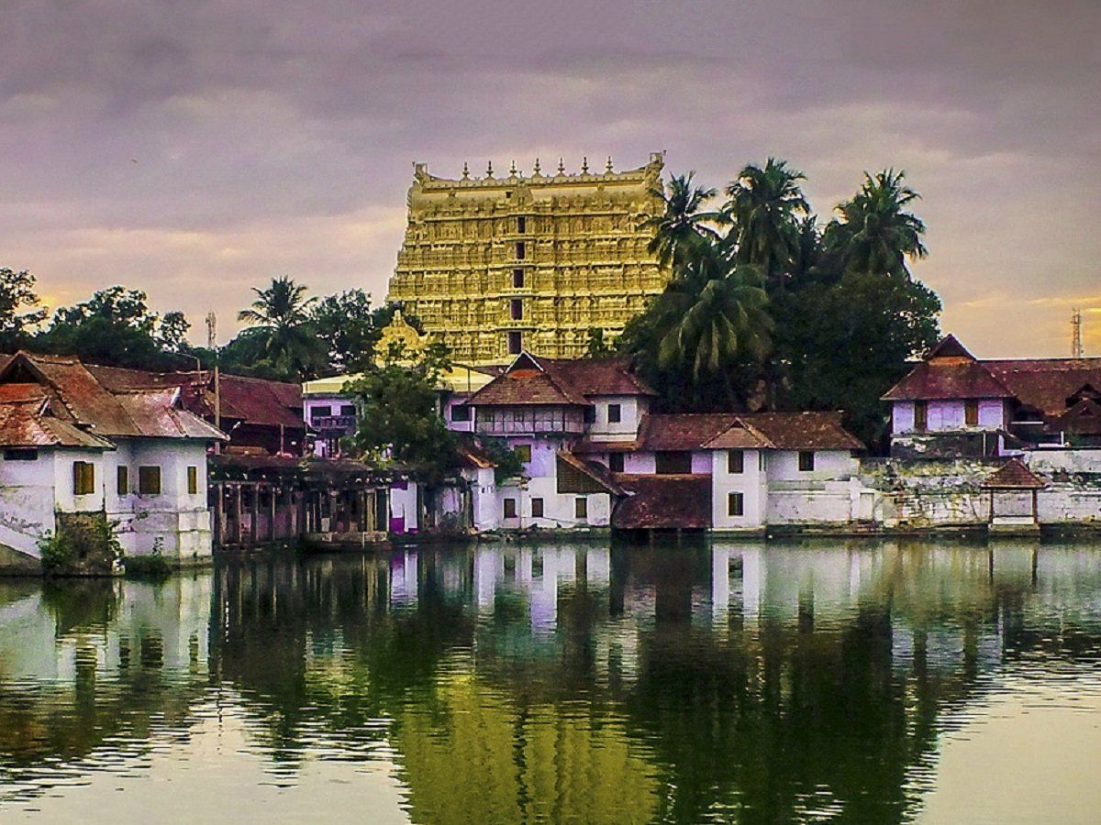

PADMANABHASWAMY TEMPLE VIEW

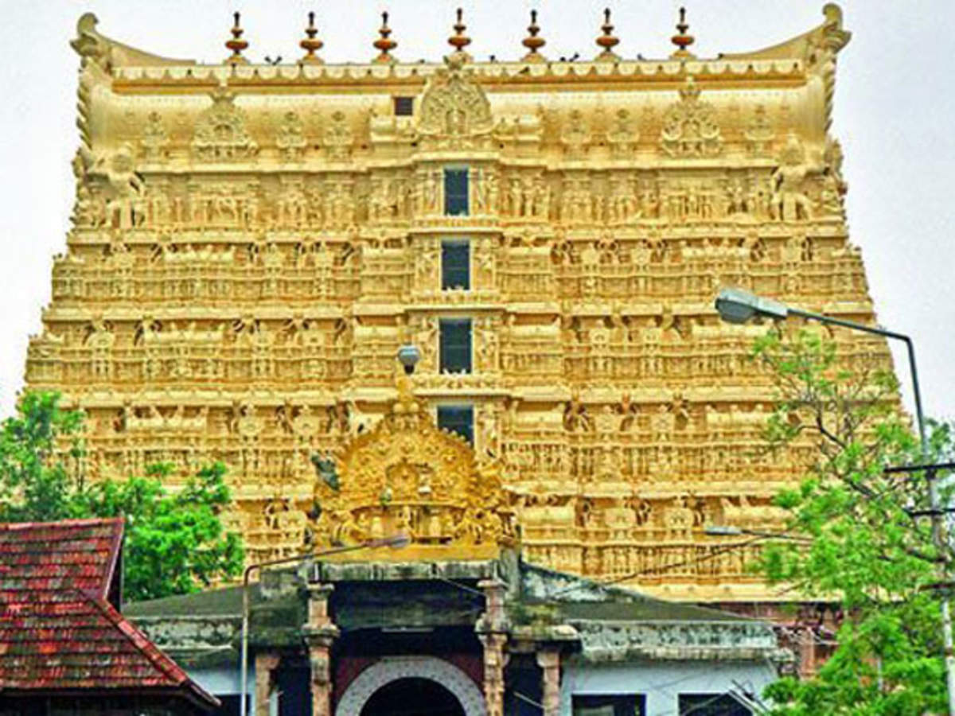 TEMPLE FRONT VIEW

In 2007, the case has been filed about the missing of jewels, ornaments and gold in the vaults. There are totally **Six** vaults in the temple. They are vault A, B, C, D, E and F. So, Supreme Court of India ordered to check these vaults with the help of Z-type security, archaeological departments, Reserve Bank of India and two engineer .One thing noted down that vault E and F are daily opened for the storage of jewels, flowers and other things and vault C and D are opened 3 times per year for festivals .However, vault A and B has not been opened for over many years (say over 500 years). For work of over 7 hours, vault A is opened but it has only wastes .After proper cleaning, the government shocked to saw that thing. They saw the vault A has tons, tons and tons of jewels, gold, diamonds and three feet gold Vishnu statue. The government collected gold and jewels from all vaults except **vault B** with a worth amount of **22 billion dollars (Rs.1,678,476,800,000/-).** After noticing that vault B looks very different from other vaults. The vault B is sealed with an enormous iron door with two massive cobras painted on it with no means of entry. The government tried many times to open the door with many advanced technologies, but it stood still and has not been opened by anyone. Vault B has been locked for many years and no key hole is found. No one knows what is inside in vault B. Scientists estimated that vault B contains more gold and diamonds than the sum of gold and diamonds on other vaults. They estimated an amount of 1 trillion dollars (Rs.76,260,000,000,000/-).

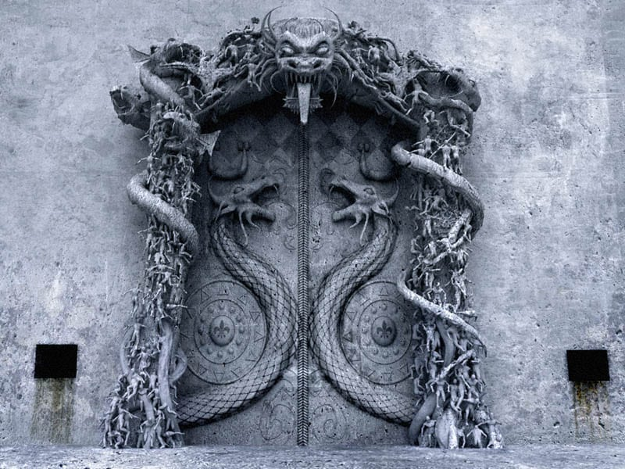

VAULT B (SEALED DOOR)

People living in surrounding temple area believe that opening the vault B may bring great misfortune to mankind. Scientists used technologies to hear the sound inside the vault B. They heard a ocean’s wave sounds. Some other people believe that the door can be portal to another world, so the vault B has been built not opened for many years. **Vault B** remains **most mysterious and unexplored thing** in the world till date. No one knows what’s inside in that vault till date!!...

JUST FOR BASIC INFORMATION (RELATED MEMES):





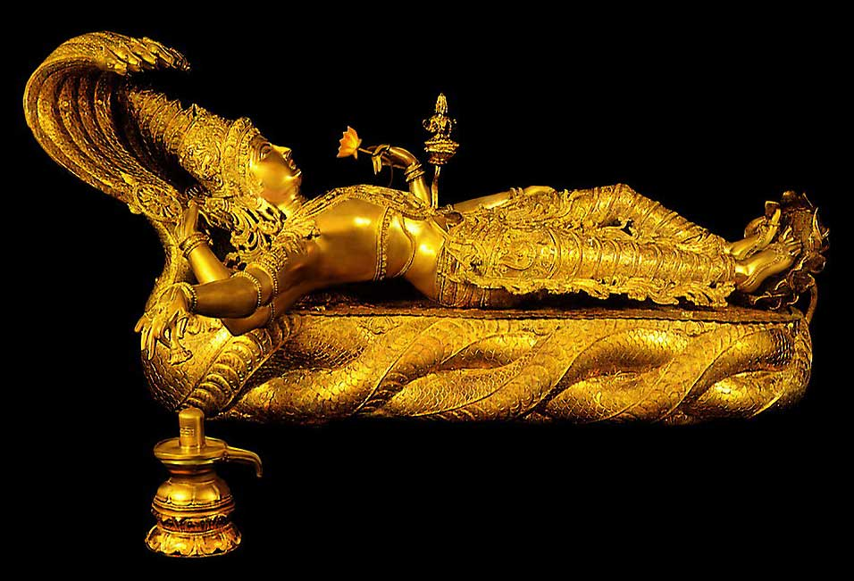

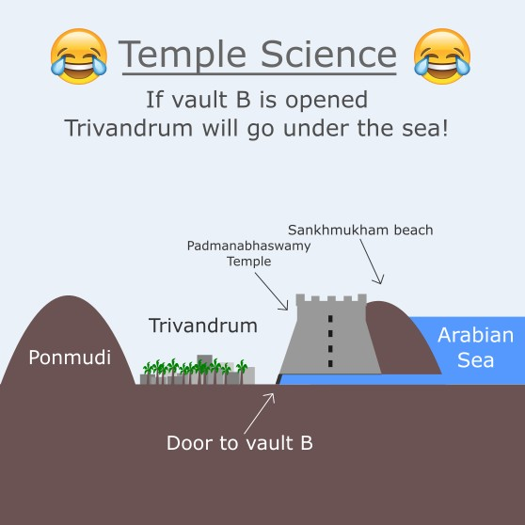

Reference links:

1. <https://youtu.be/WElk_qmEaYc> (Tamil)
2. <https://en.wikipedia.org/wiki/Padmanabhaswamy_Temple>
3. <https://youtu.be/WElk_qmEaYc> (Tamil)